**Homework 6**

**Problem1: The Integration**

**1. Using the Trapezoidal Rule:**

**The integral of the function *f(x)*, evaluated from a to b, is expressed as**

** that represents the area under the function *f(x)* from x=a to x=b ,as**

*y*



*x*

*f*(*x*)

*b*

*a*

Fig 1: **Area under a curve**

*y*

*x*

*f*(*x*)

*y*1

*y*2

*y*3

*y*4

*y*5

*a = x*1

*x*2

*x*3

*x*4

*x*5 = *b*

Fig 2: **Spaced intervals**

*y*

*x*

*f*(*x*)

*y*1

*y*2

*y*3

*y*4

*y*5

*a = x*1

*x*2

*x*3

*x*4

*X5*= *b*

A1

A2

A3

A4

*h = x*2 － *x*1

= *x*3 － *x*2 = **…**

Fig 1: **Four trapezoids**

**The total area under the function *f(x)* from** *x*1 **to** *x*5 **is** A1**＋**A2 **＋**A3**＋**A4**=**

**× (** *y*1 ＋*y*2 **) ×***h*＋**× (***y*2＋*y*3**) ×***h*＋**× (***y*3**＋***y*4 **)×***h*＋**× (** *y*4 ＋*y*5 **)****×***h*

＝× (*y*1 ＋*y*5 **) ＋（***y*2**＋***y*3**＋***y*4**）×** *h*

**＝**＝× 〔(*y*1 ＋*y*5 **) ＋ 2 ×（***y*2**＋***y*3**＋***y*4**）**〕

**In general, *Area* =  =** 〔***f(a)*** + ***f(b)*** + 2  〕

**where *h* = , Note that the interval 〔*a, b*〕is divided into *n* subintervals**

**2. Using the rectangular rule:**

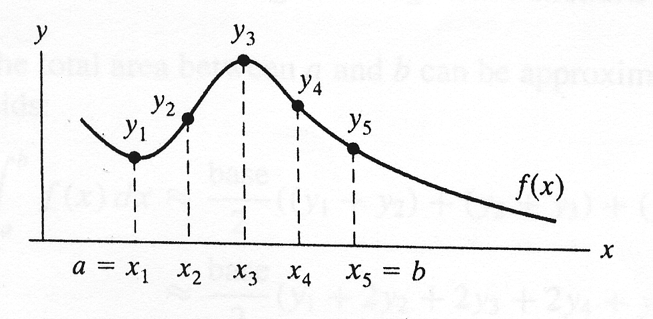

*h = x*2 － *x*1

= *x*3 － *x*2 = **…**

**The total area under the function *f(x)* from** *x*1 **to** *x*5 **is**

*h* ×*y*1 **＋***h* ×*y*2**＋***h* × *y*3**＋** *h* ×*y*4 = *h* ×（*y*1＋*y*2**＋***y*3**＋***y*4）

**In general, *Area* =  =** *h* × 

**1. Using these two methods to find the area bounded by**

**From** *a***= 0** *b***= 10 *f(x)* = 8 ＋3＋ 6*x*＋ 10**

**Given that h = 0.1**

**2. From the result :**

**(a). Discuss these two methods.**

**(b). The interval 〔*a, b*〕is divided into *n* subintervals .**

**Increase the value of n that is decrease the value *h*.**

**You can try any other values of h.**

**Problem 2: Write a program that prompts the user to input three numbers. The program should then output the numbers in ascending order. (由小排到大)**

**Problem 3. Write a program that prompts the user to input the x-y coordinate of a point in a Cartesian plane. The program should then output a message indicating whether the point is the origin, is located on the x (or y) axis,**

**or appears in a particular quadrant.**

**For example:**

**(0,0) is the origin**

**(4,0) is on the x-axis**

**(0,-3) is on the y-axis**

**(-2,3) is in the second quadrant**

**(-1,-9) is in the third quadrant**

**Problem 4. Use the switch syntax to solve this problem**

**Write a program that mimics a calculator. The calculator provides only 4 arithmetic operations: +, -, *, /. The program should take as input one integer , the operator that the operation to be performed and the other integer. It should then output the numbers, the operators, and the operation result.**

**For division, if the denominator is zero, output an error message**

**If the input operator is not one of +, -, * , / then also output error message**

**The user can continue to execute the program until the user inputs**

**‘N’ or ‘n’ to stop the program.**

**Some samples input/output as follow:**

Please input integer, the operator and integer:

3 + 4

The result: 3 + 4 = 7

Continue or not : Y

Please input integer, the operator and integer:

3 / 0

The denominator cannot be zero

Continue or not: Y

Please input integer, the operator and integer:

13 * 5

The result: 13 * 5 = 65

Continue or not: N

**Problem 5.** Write a menu-driven program that has the following options:

1. Factorial of a number
2. Prime or not
3. Odd or even
4. Exit

Once a menu item is selected, the appropriate action should be taken and once this action is finished, the menu should reappear. Unless the user selects the “Exit” option, the program should continue to work.

Hint: Make use of an infinite **while** and a **switch** statement.